NODE JS

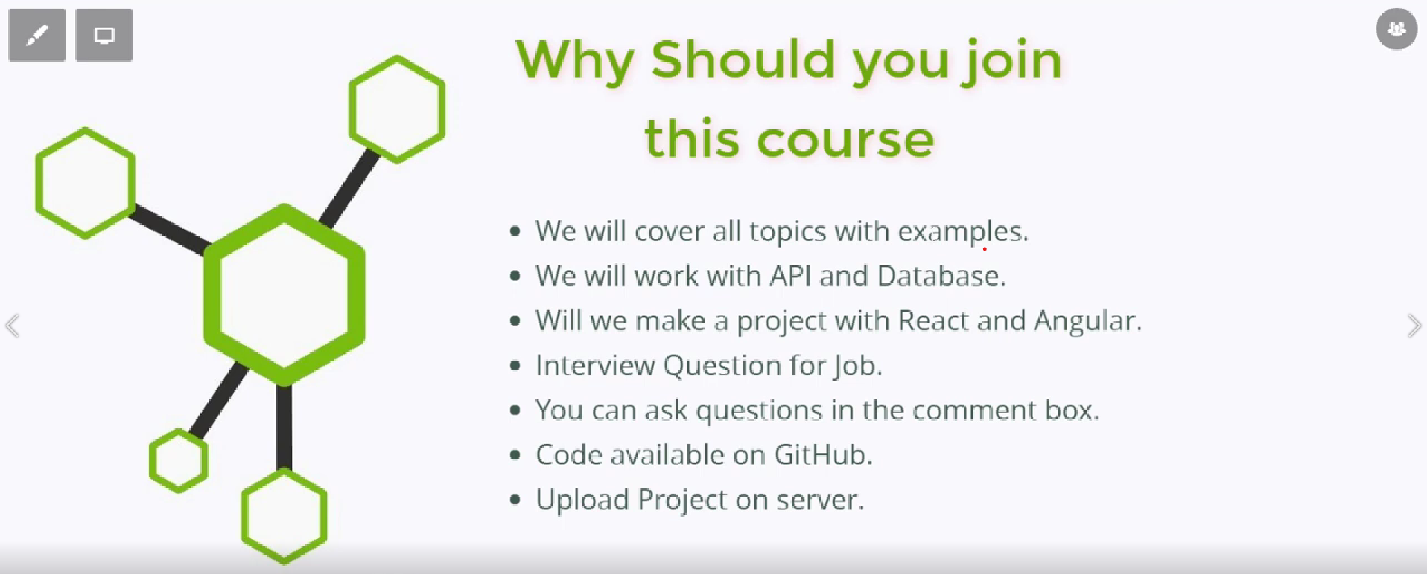



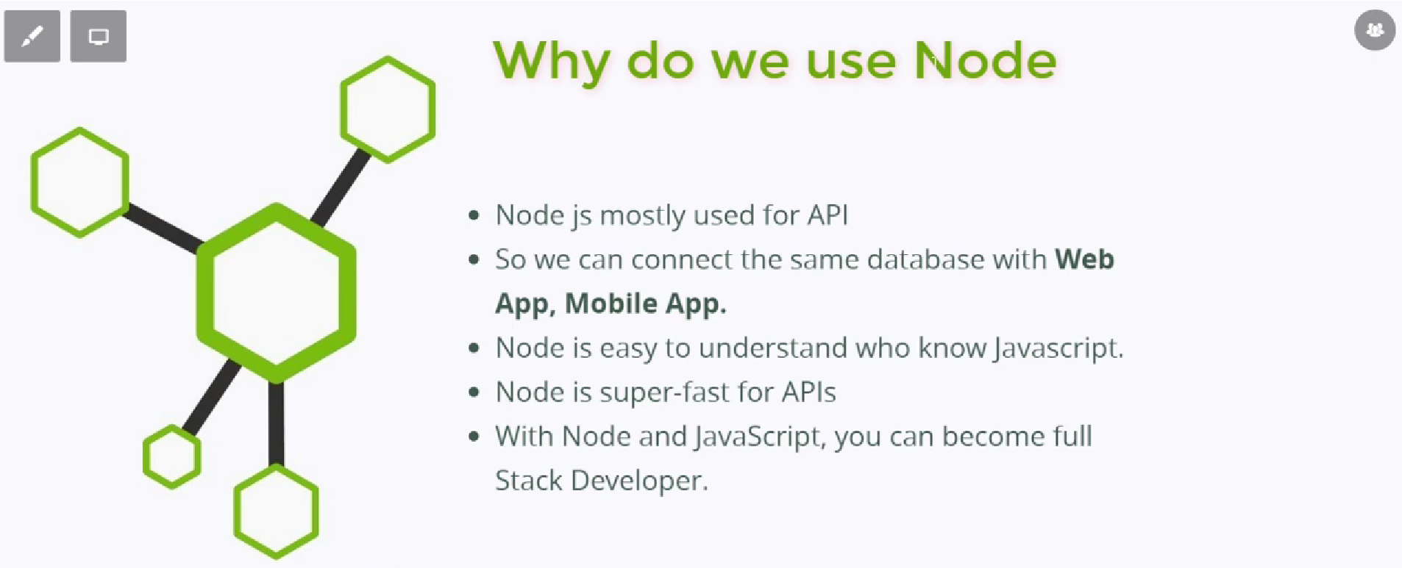
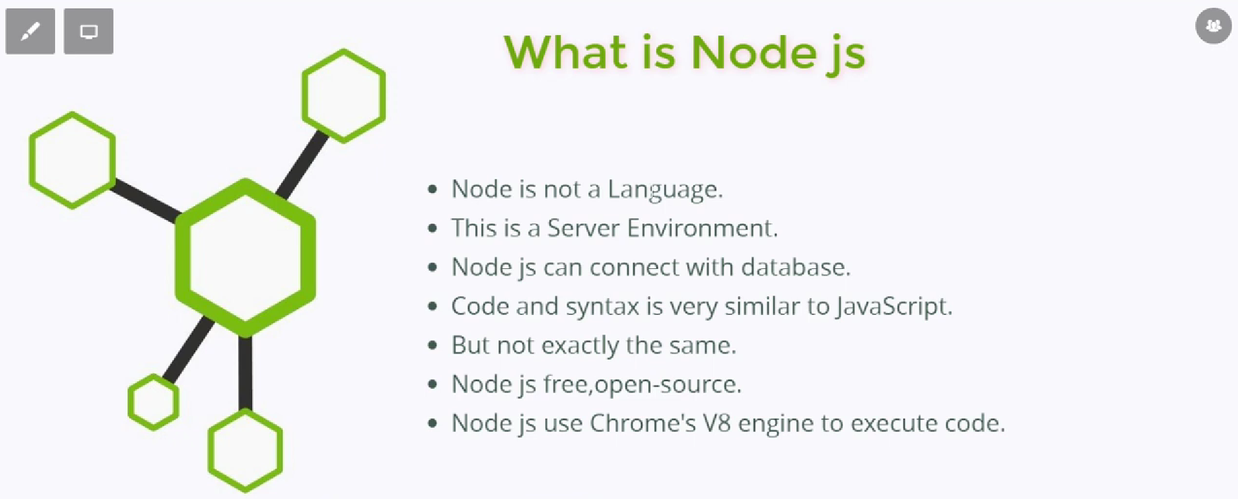
-Node Js is not language.
- It is a server-Side environment.
-It Advanced environment of Javascript.
-For example we cannot use database in the Javascript.
-But with Node Js we can perform operation regarding Database, File Creation, Network.
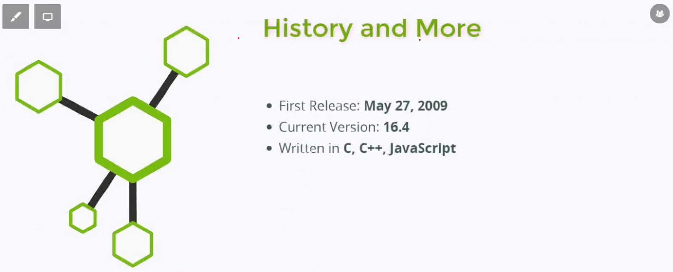
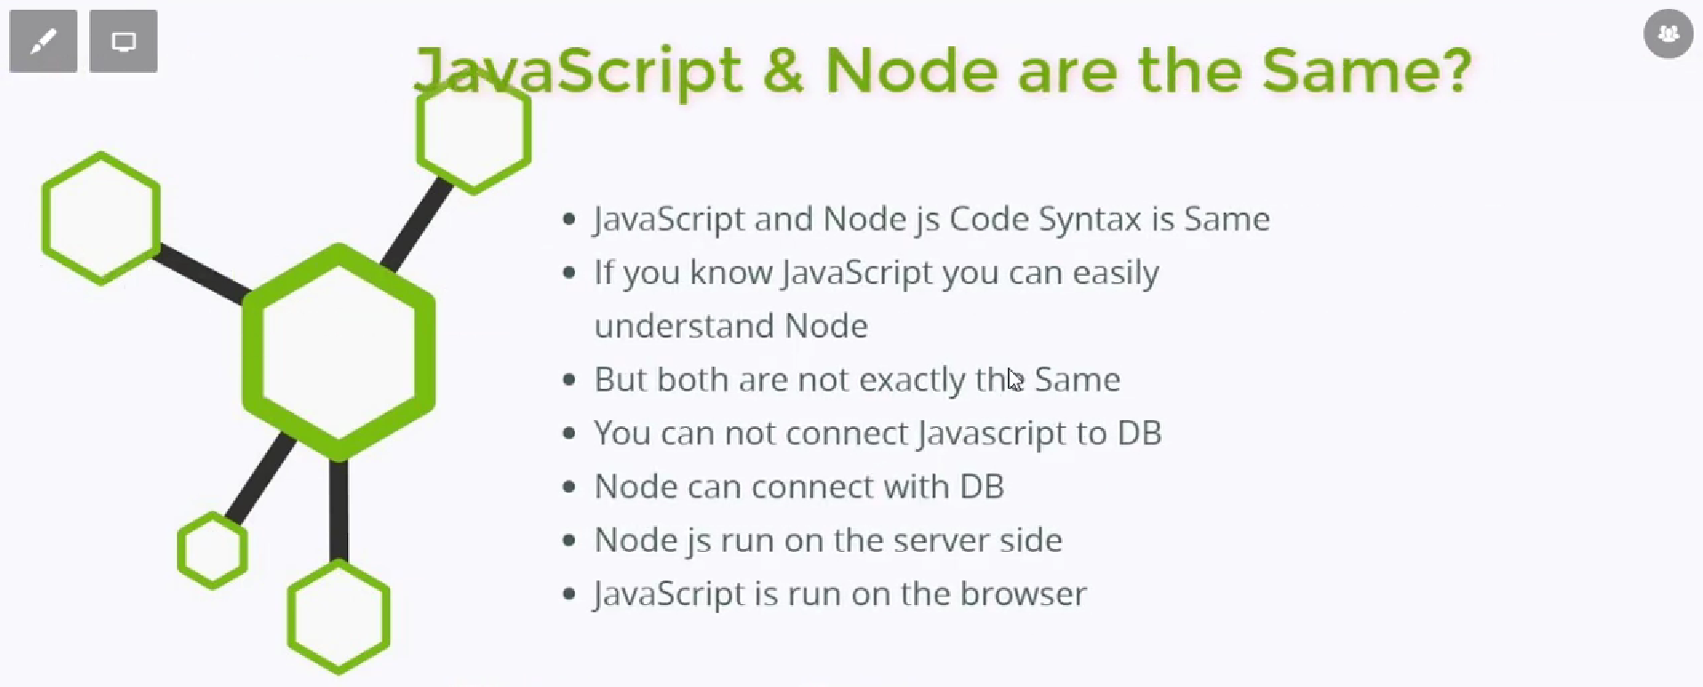

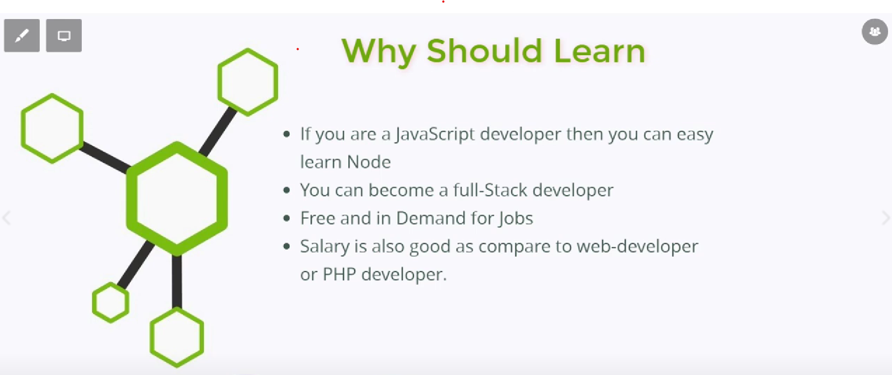

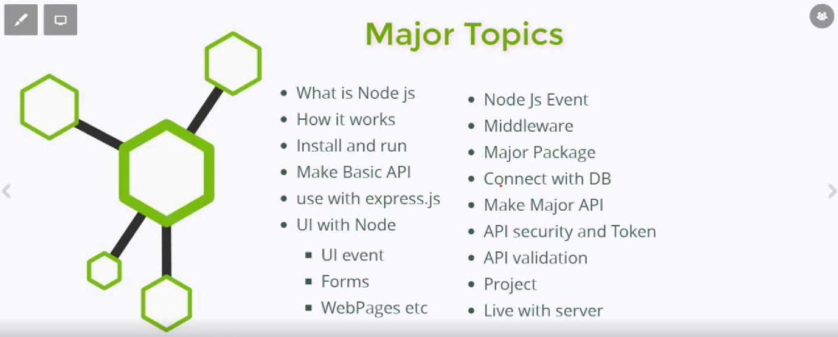

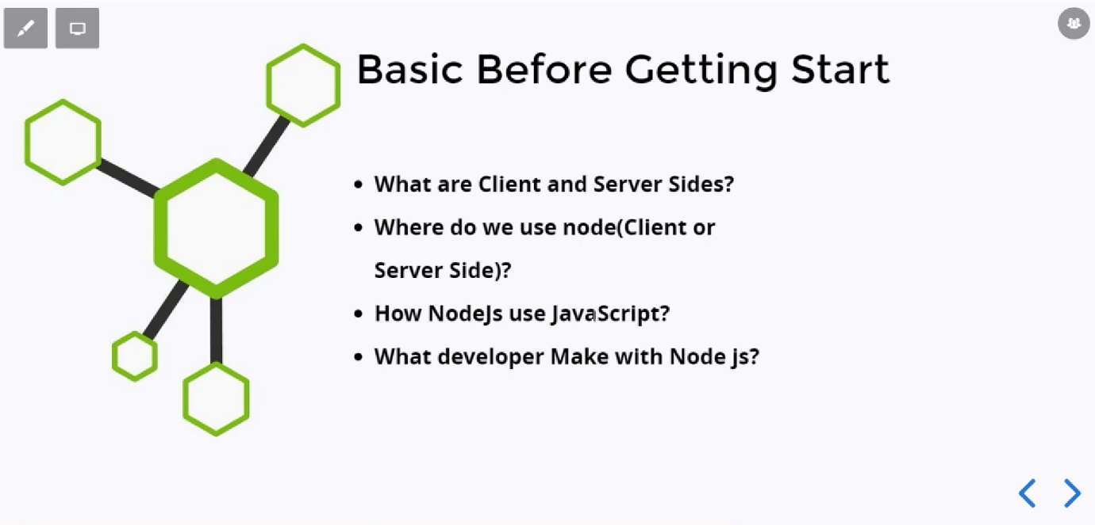

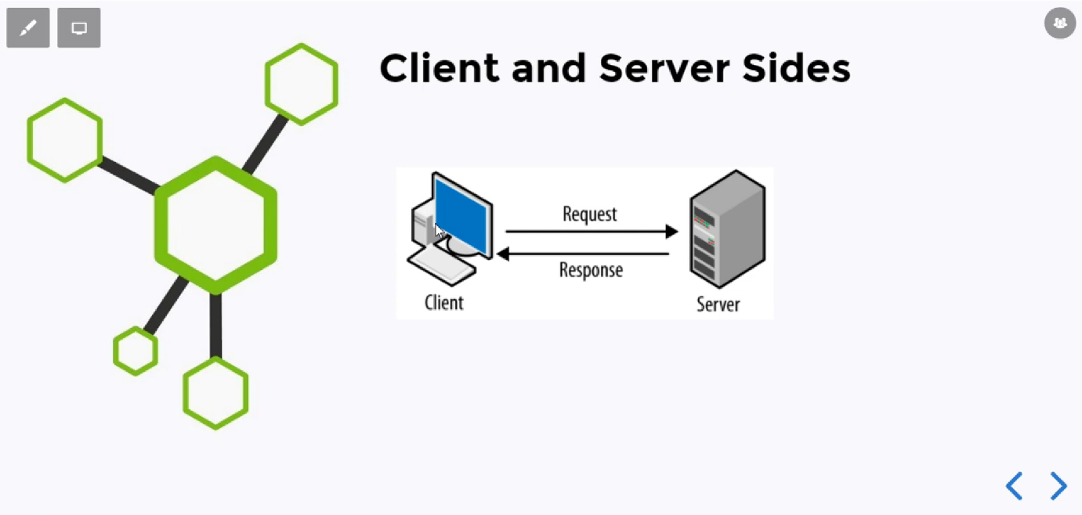

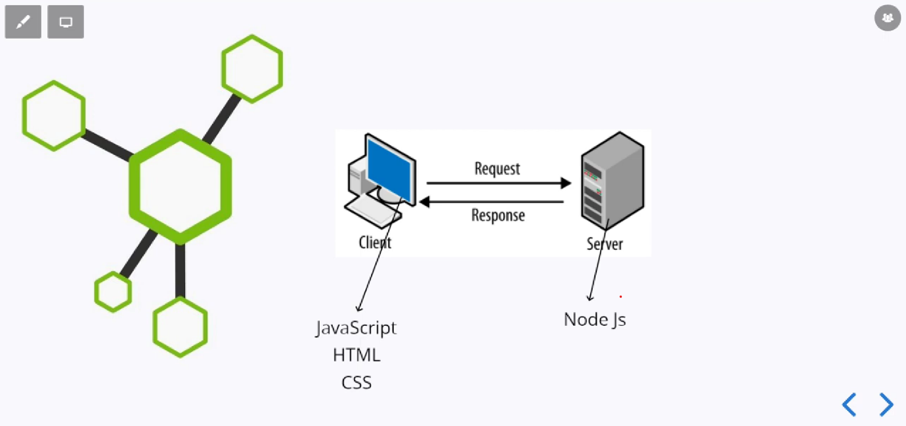

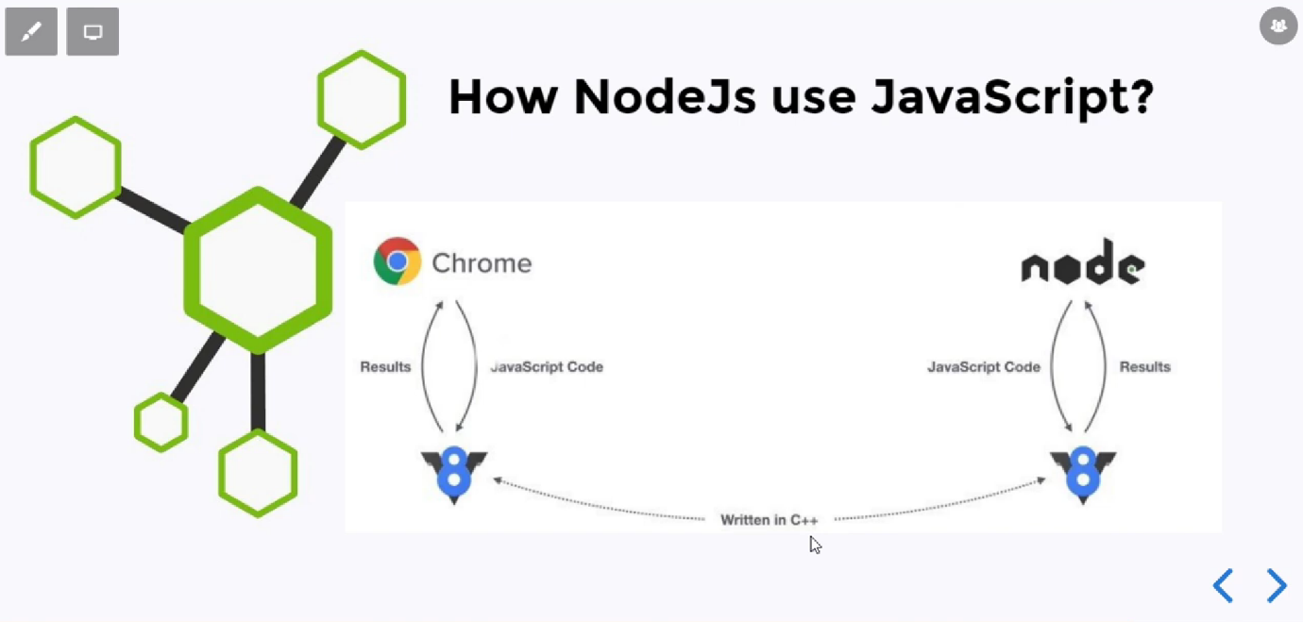
-It uses the Javascript Internally.
-Node Js uses the V8 Engine to execute the Javascript Code.
-It is server side environment.
-Chrome Also Use the V8 Engine and Node Js also use the V8 engine to execute the code.
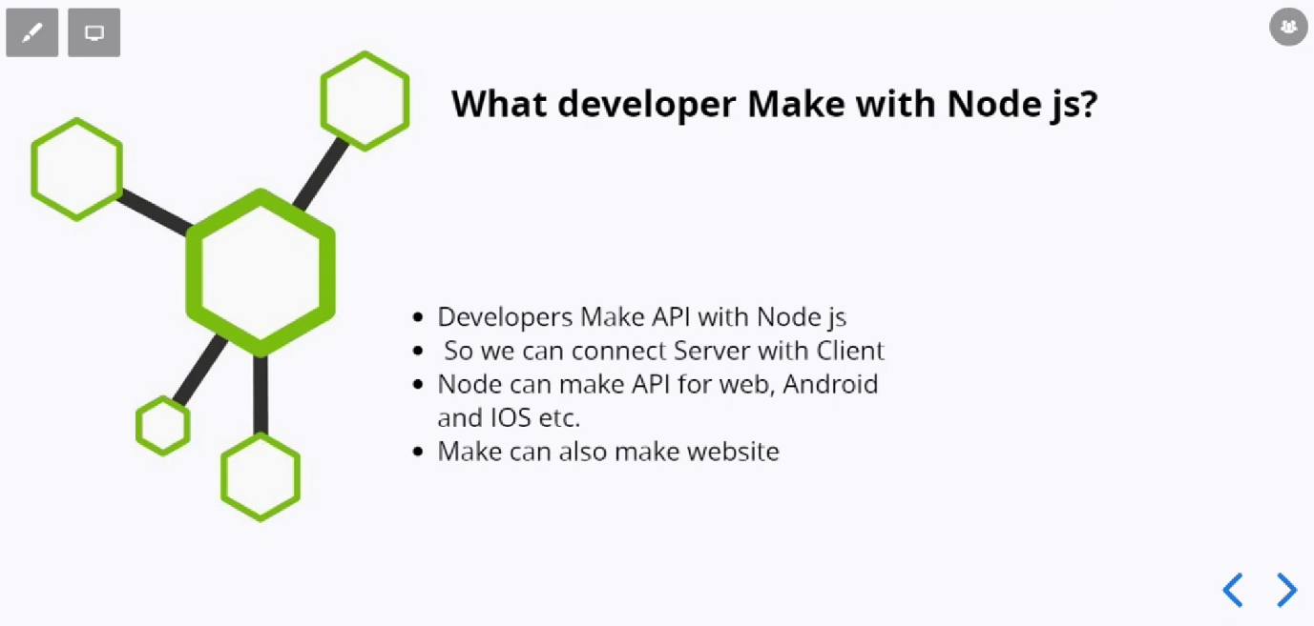

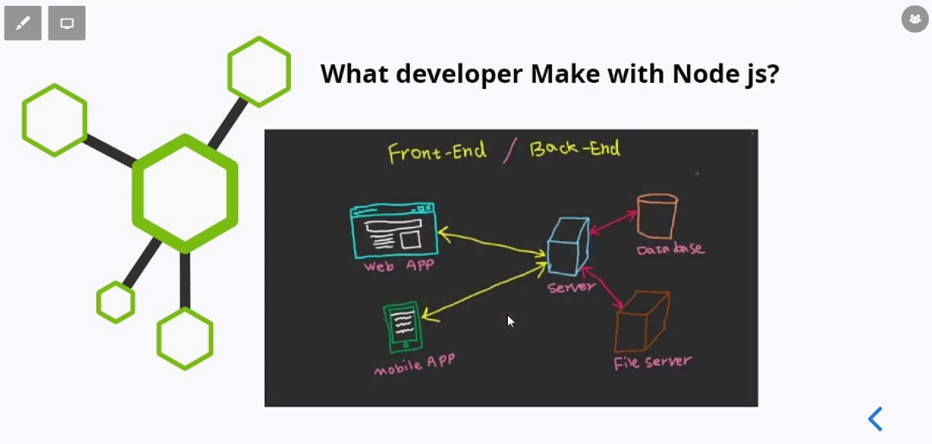
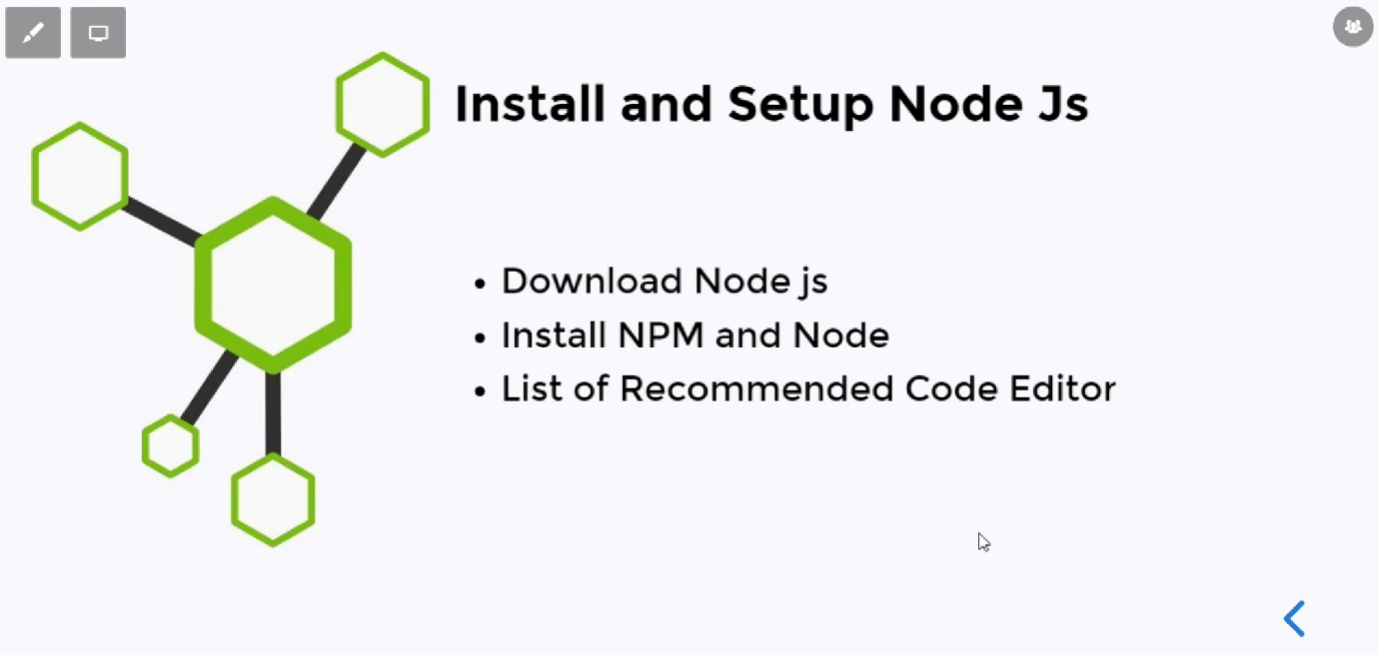
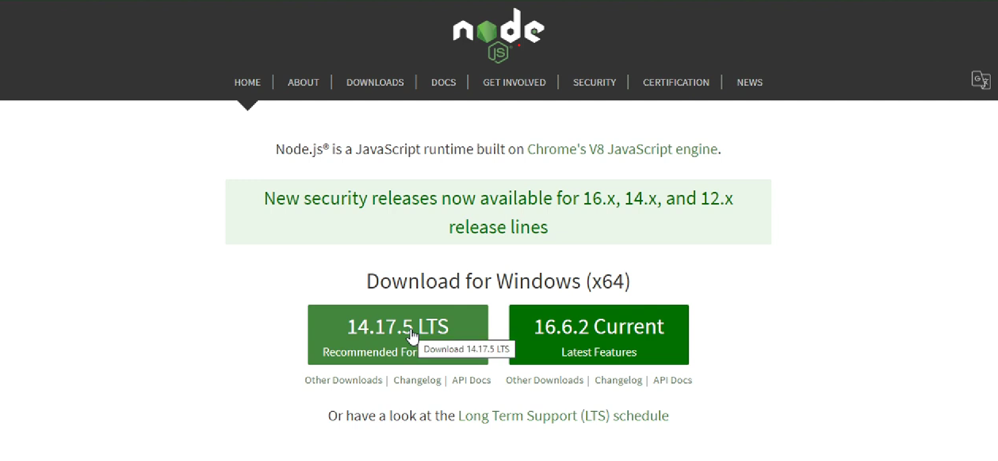

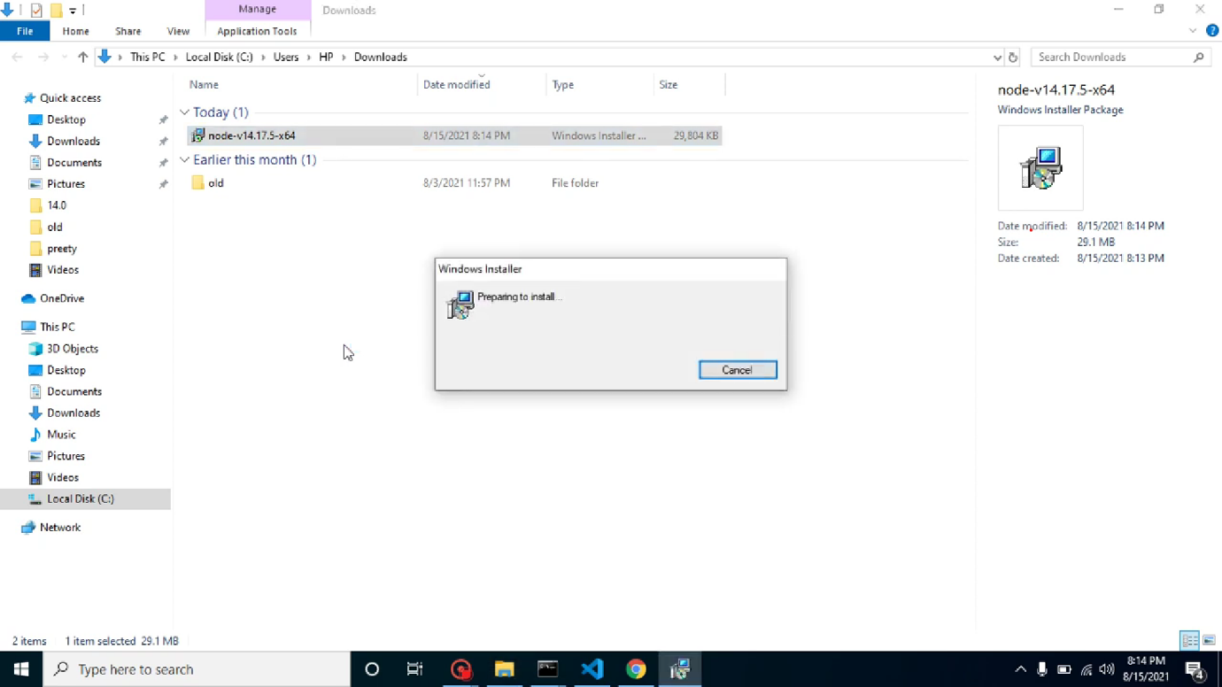

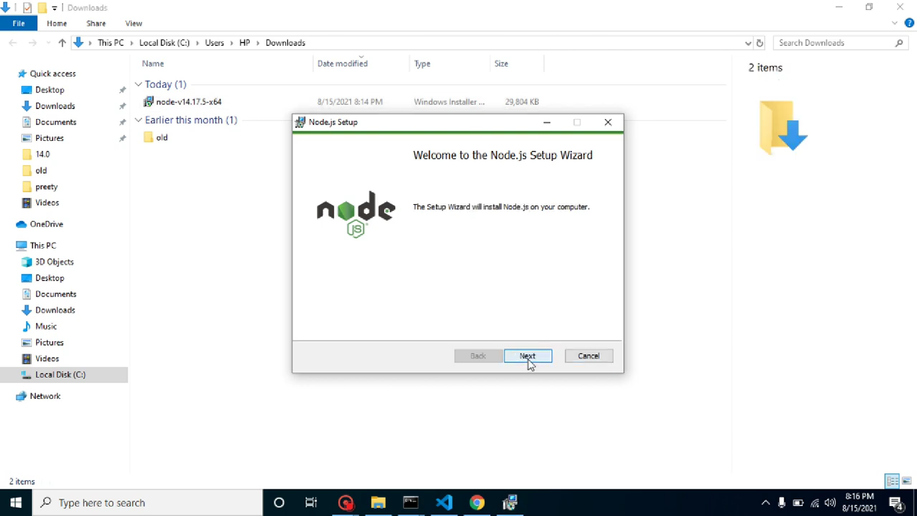

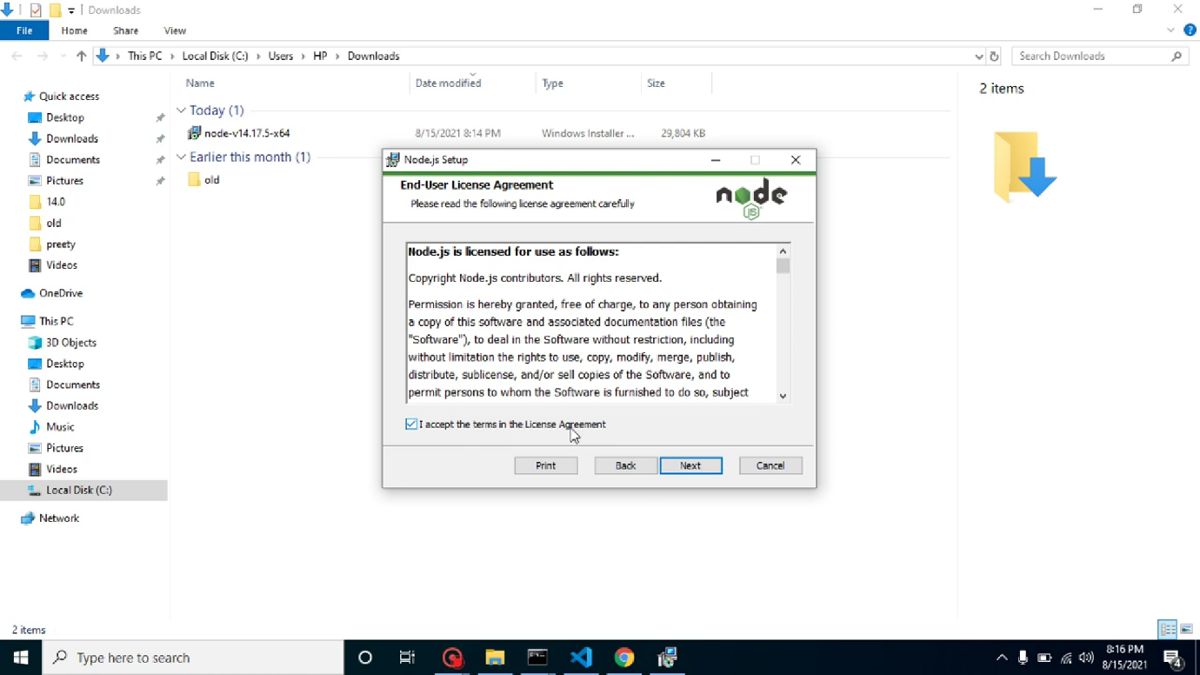
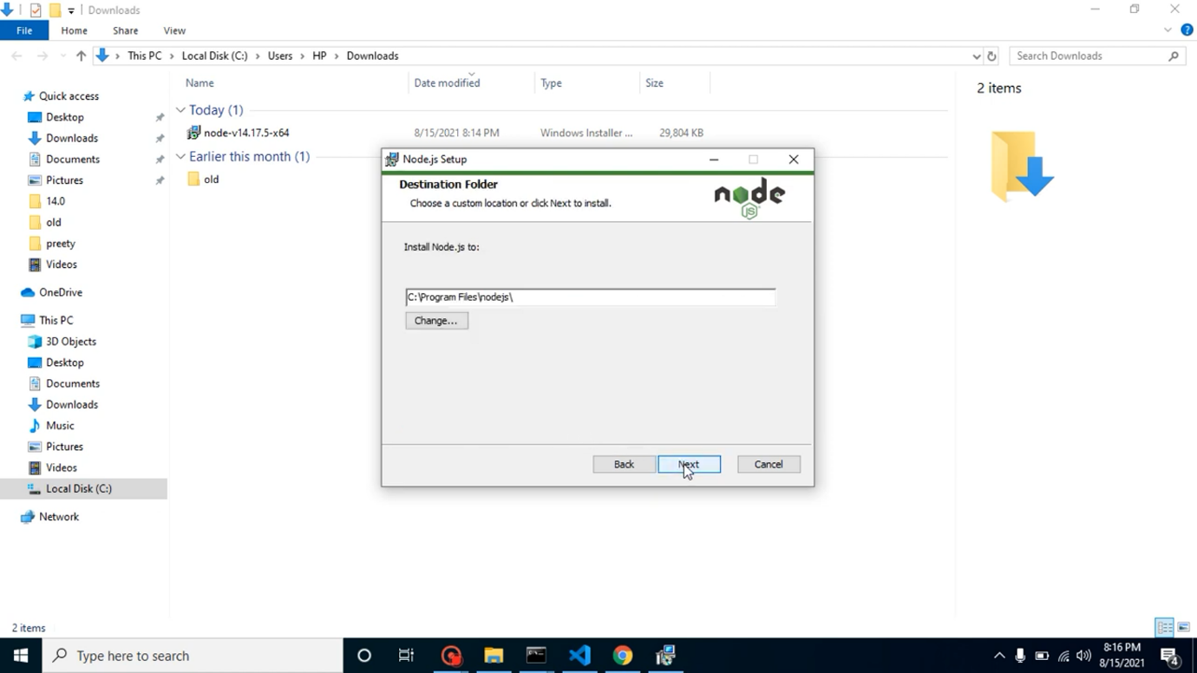

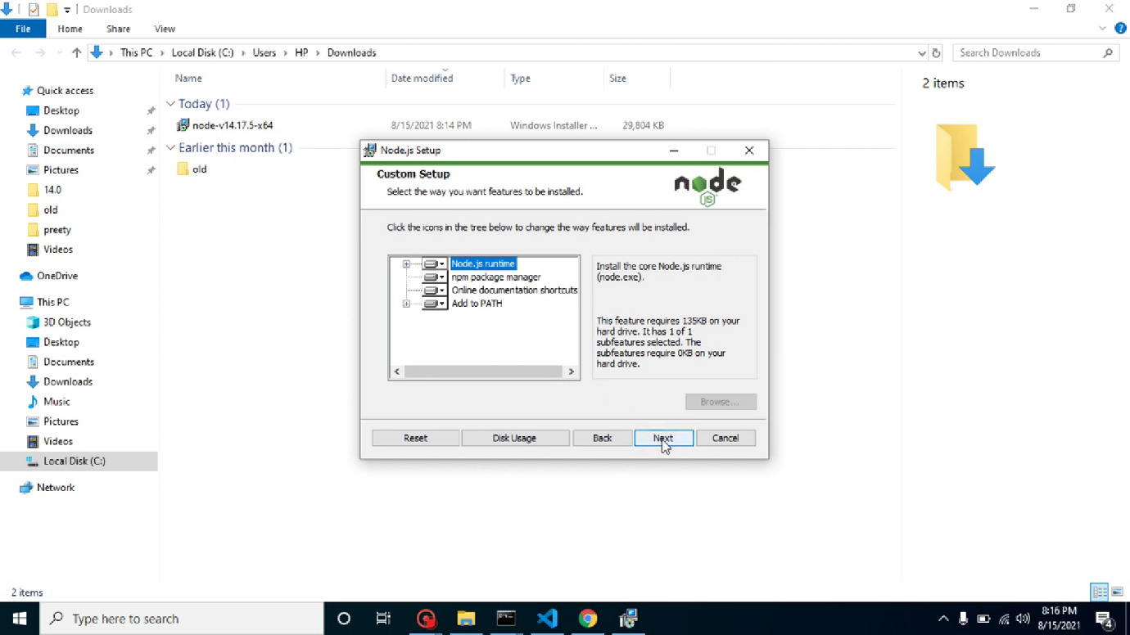

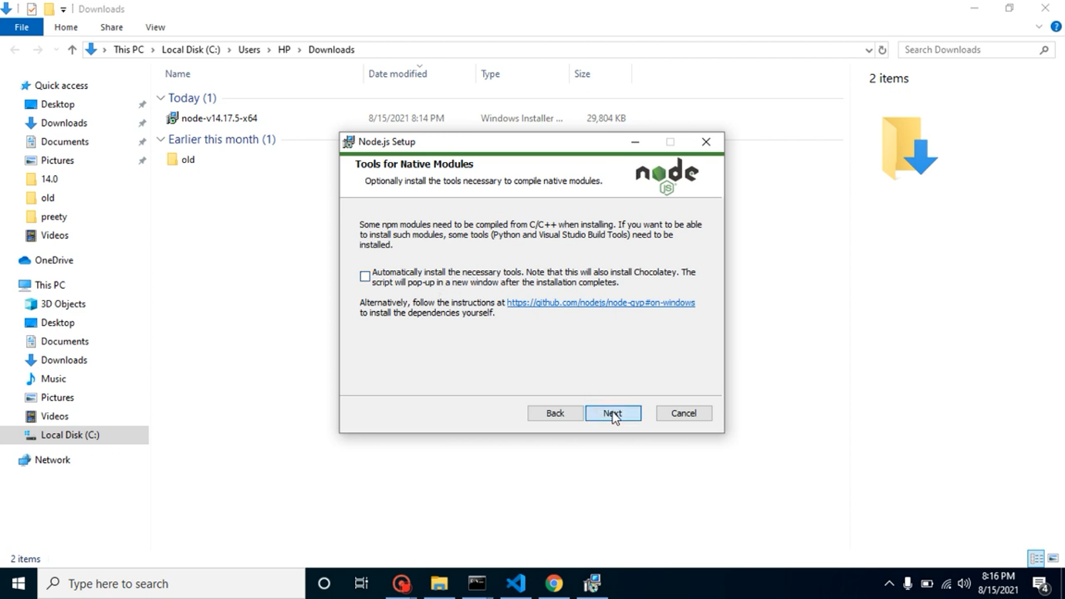

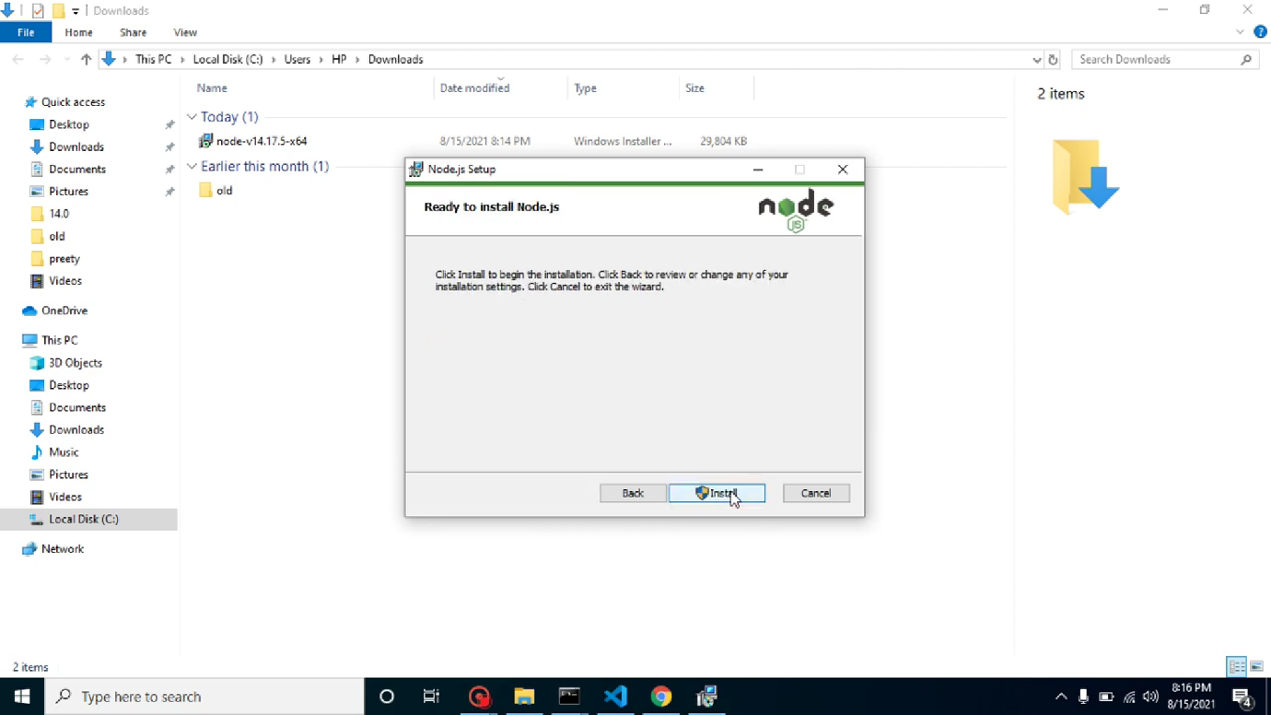
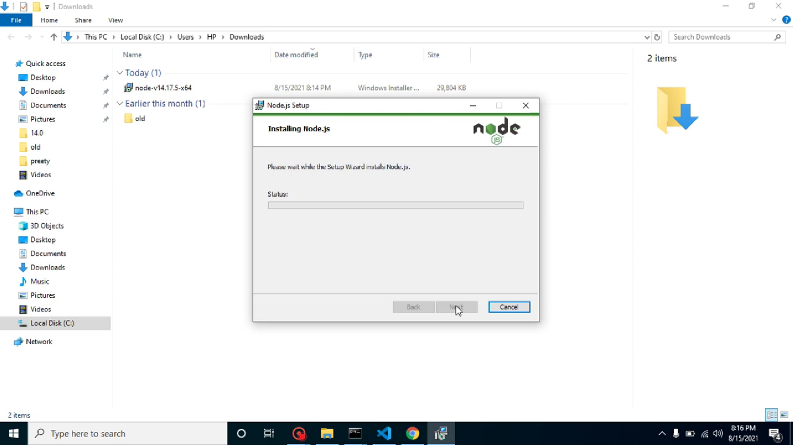

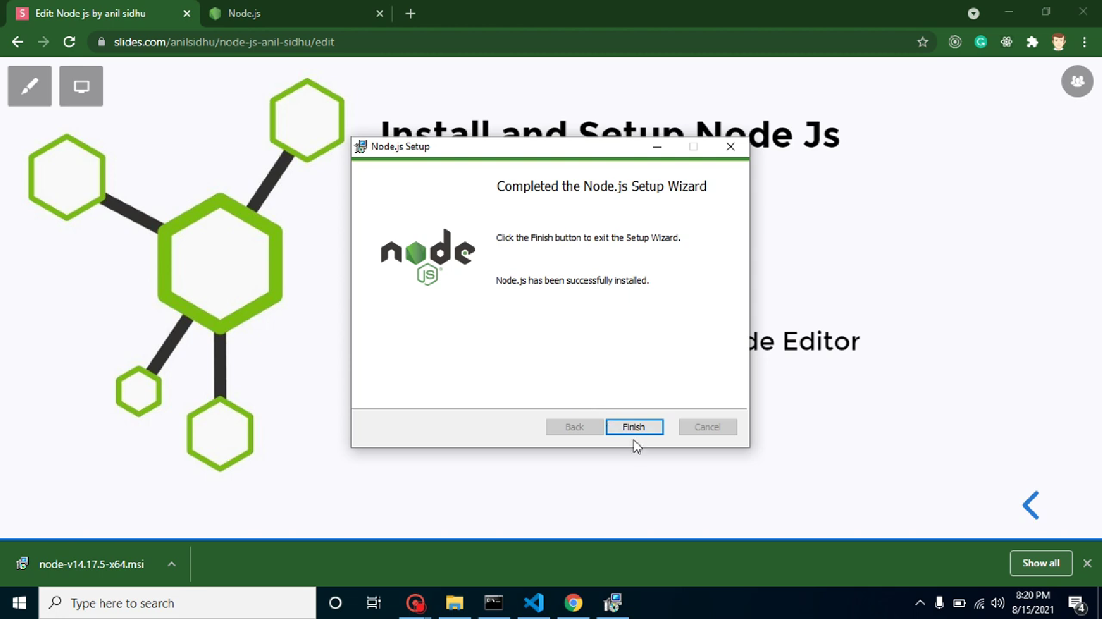

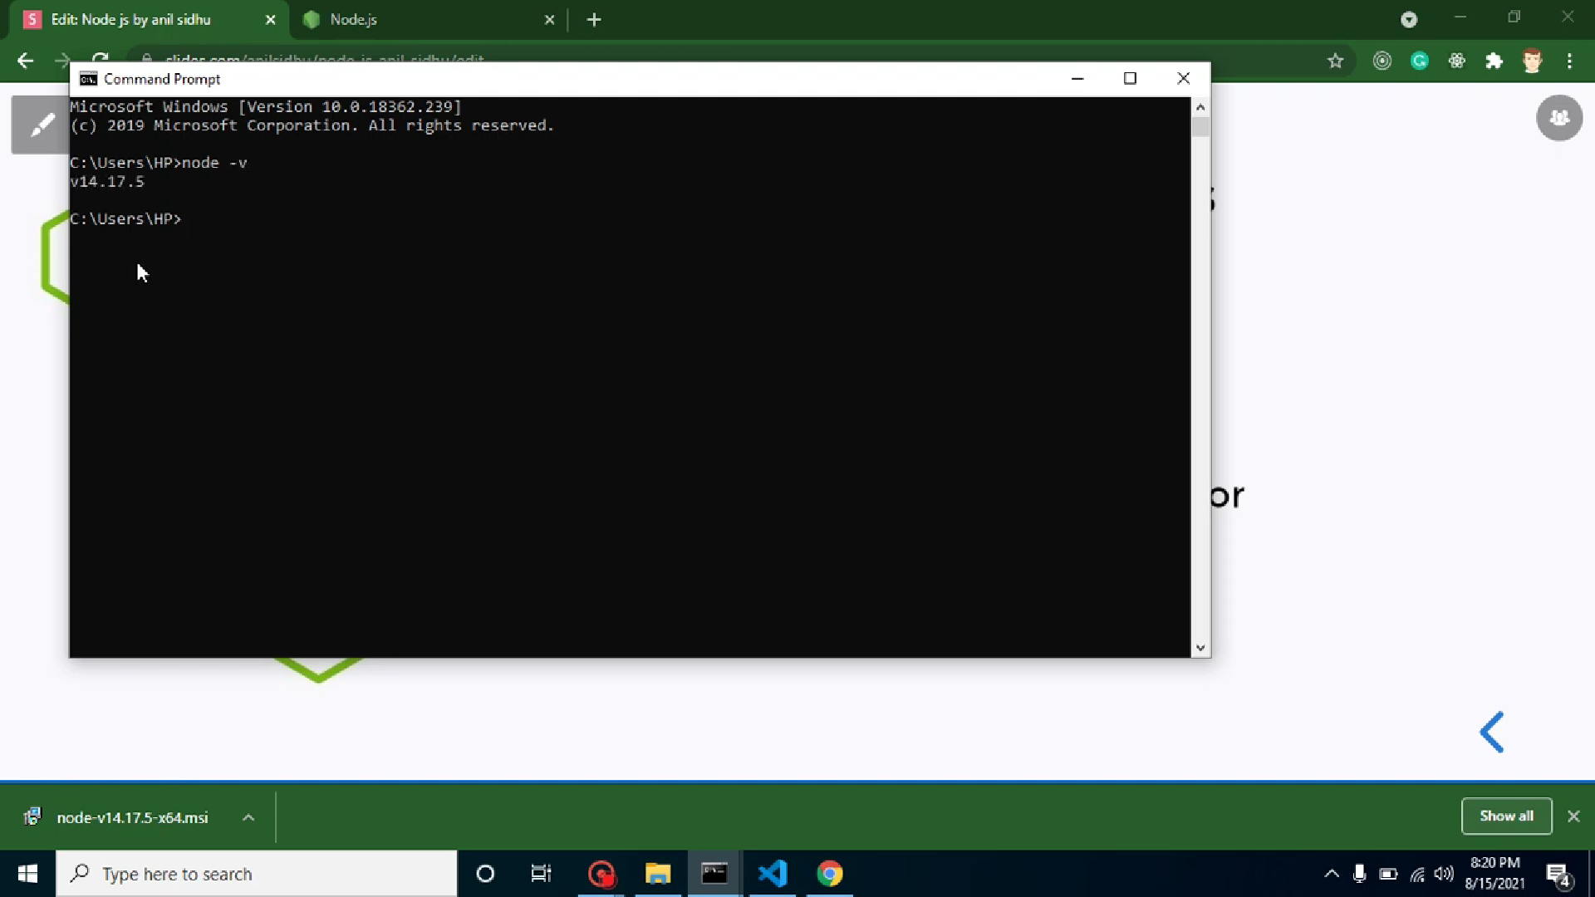
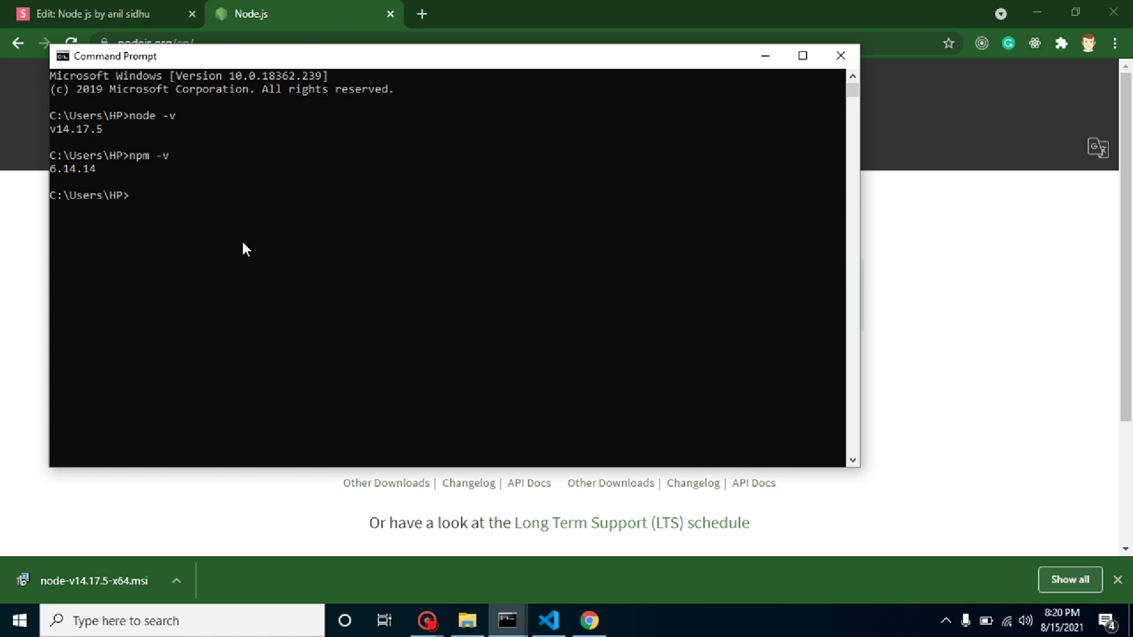
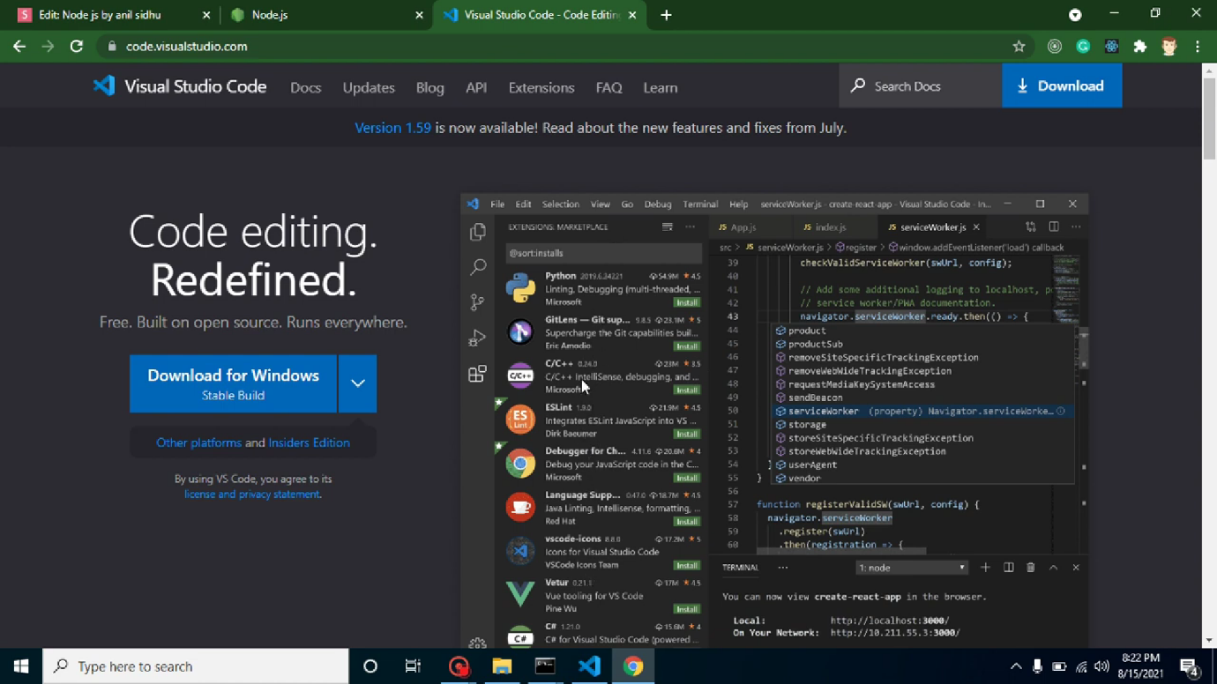

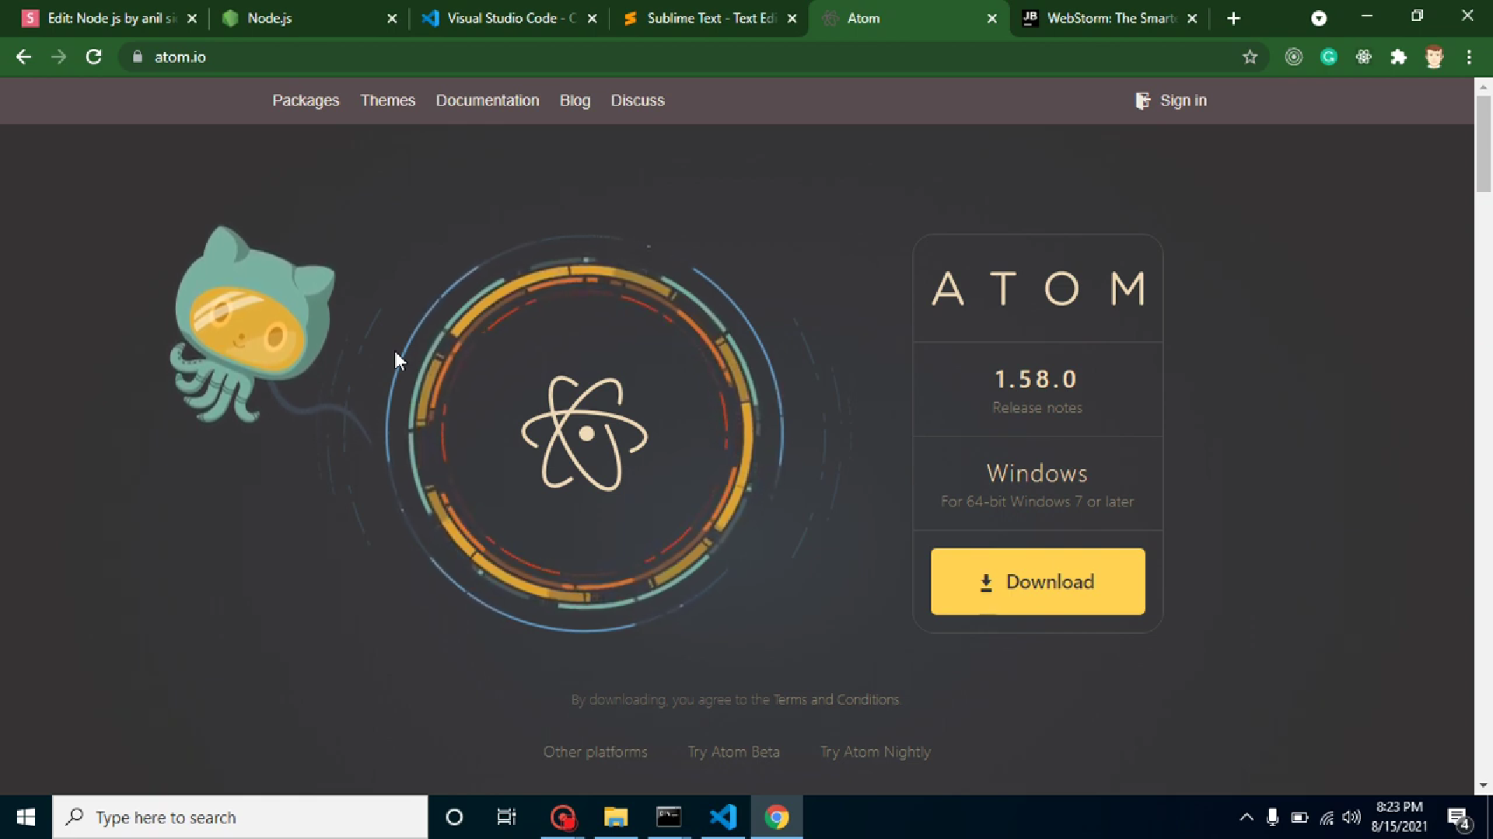
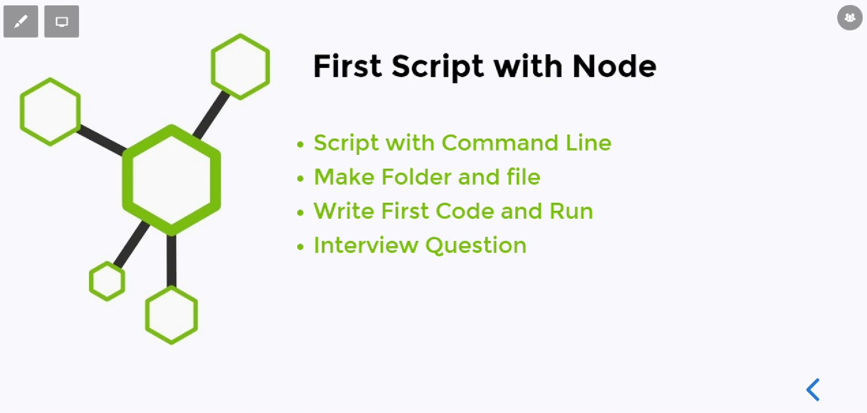
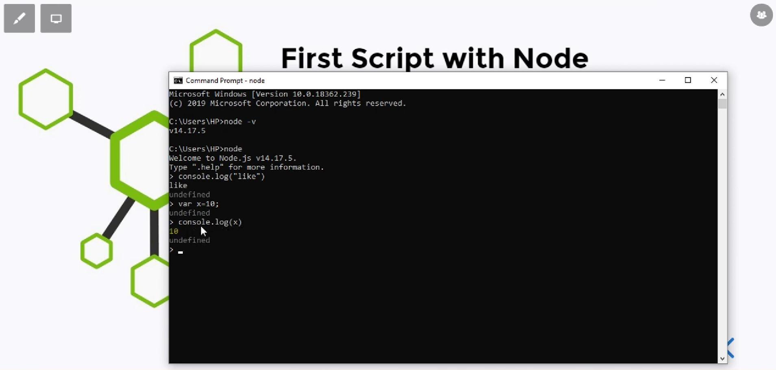
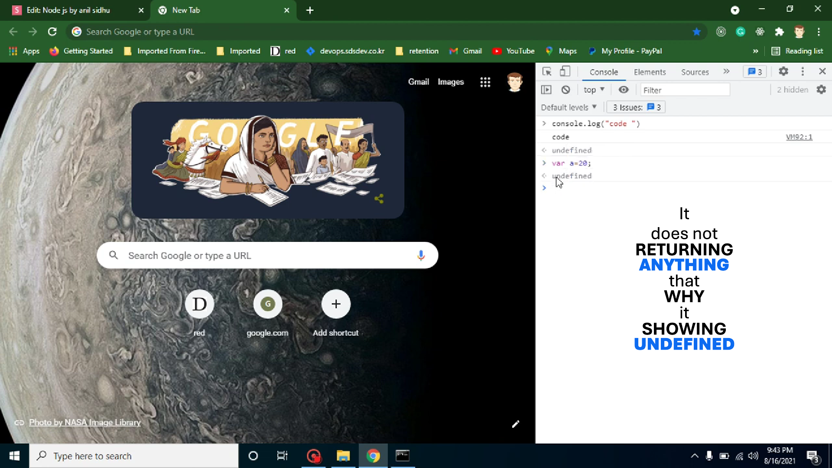
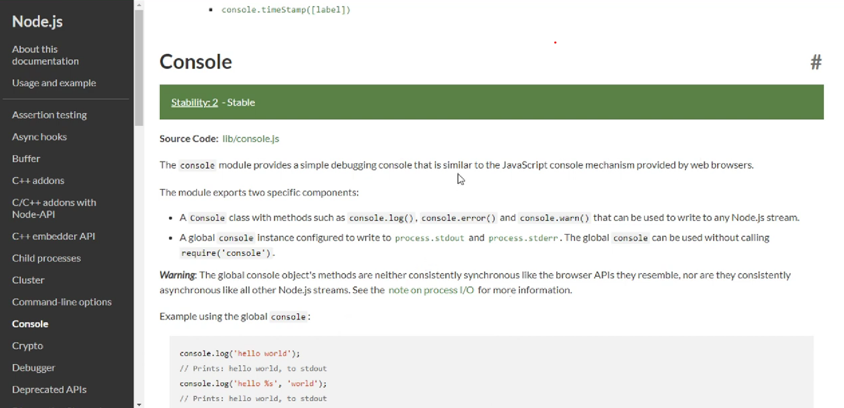
-The Browser console and Javascript console It is Different but have the similar working.
-The Browser Console it is a function.
-The console from the Node js it is module.

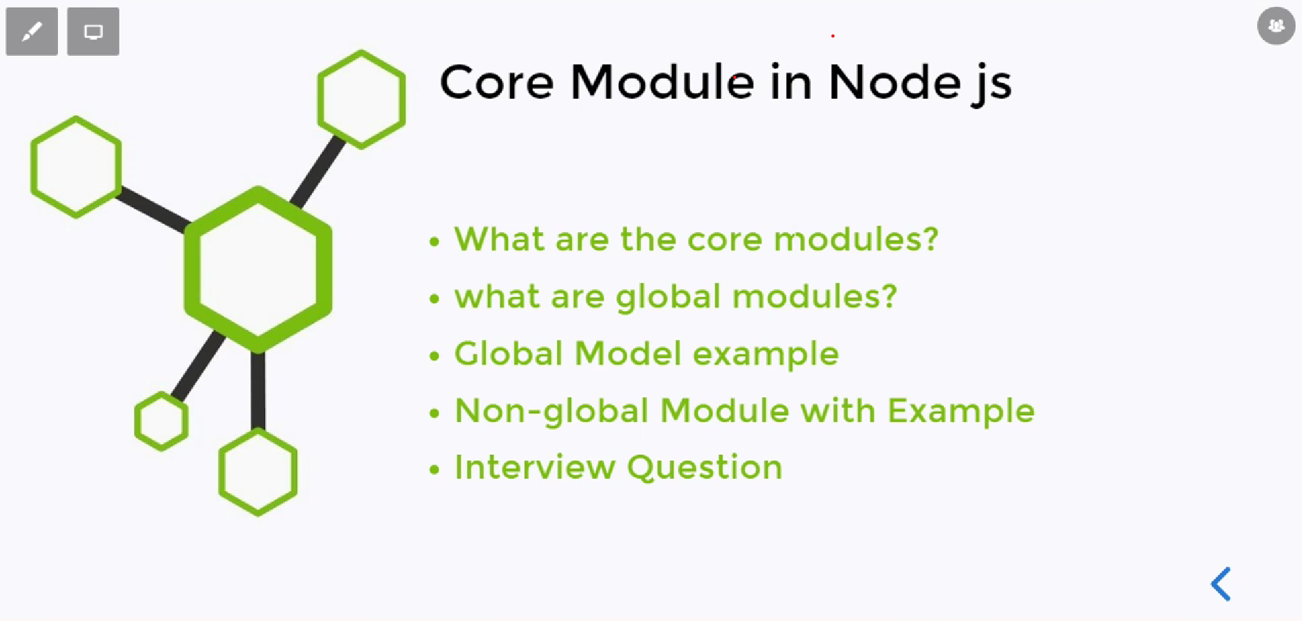
-The Core Modules have Two Types
1]Global Modules
-For Global Modules We does not need to import.
Ex : console.log(), __dirname, __filename.
2]Non-Global Modules
-For Non-Global Modules We need to import them
Ex : fs, path, os, url etc.

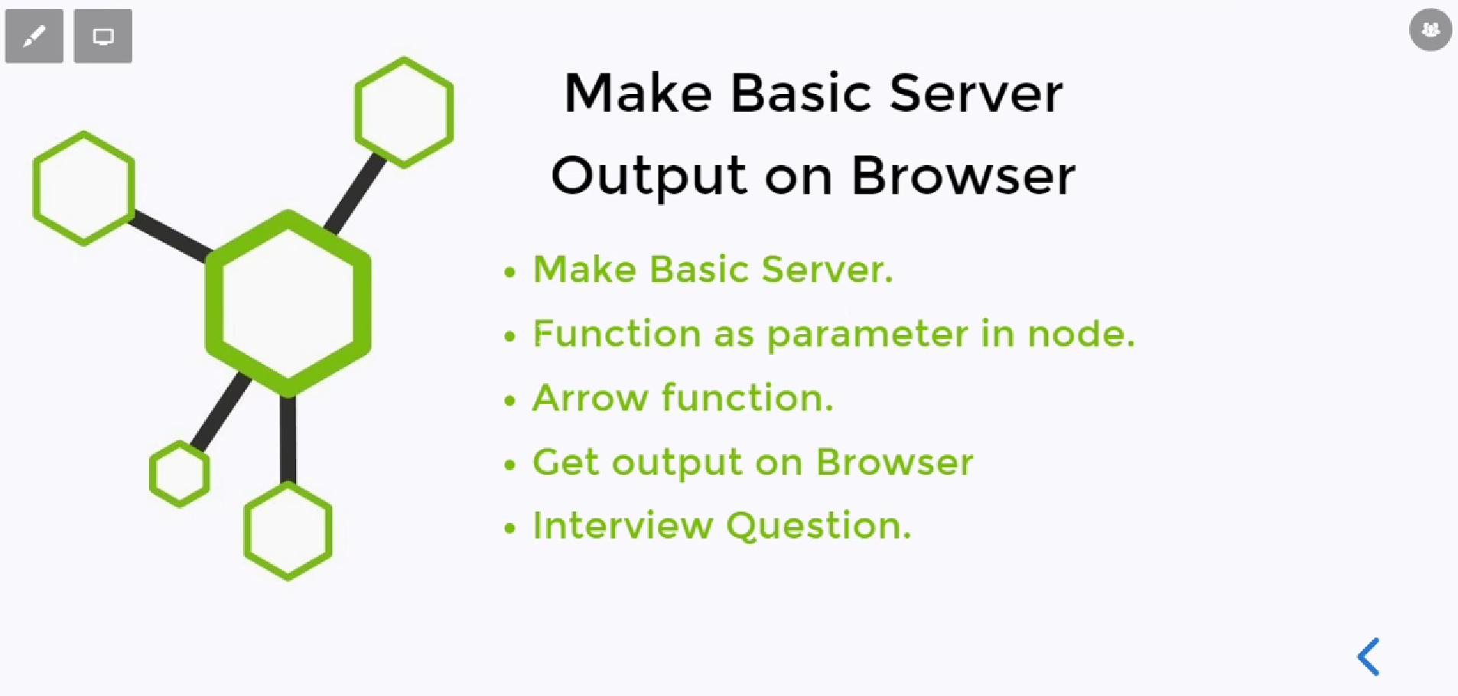
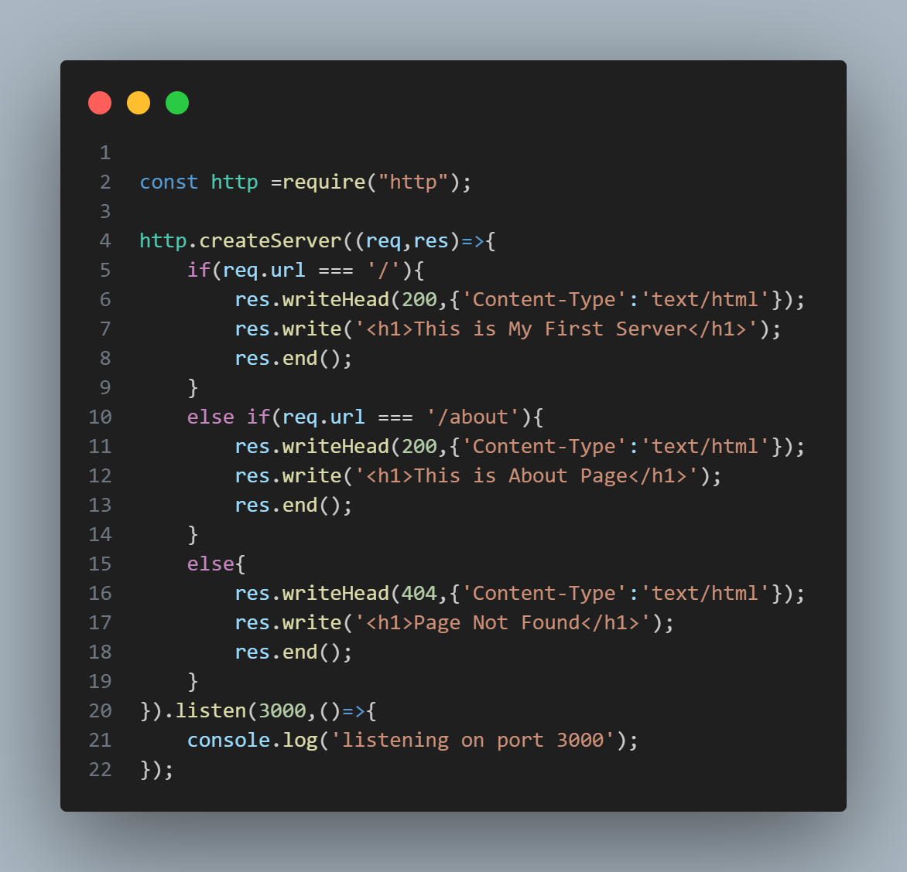
-Using The http We can create basic Server.
-The http module the takes the request and give response.
- For Getting The output in Browser you have to start server.
-If you have done any changes then have to make sure to Re-Start the Server.
http.createServer (Built-in Node.js)
- Part of Node.js core (require('http')).
- Very low-level: You have to manually handle routing, headers, responses, etc.
- Ideal when you want full control and are comfortable building a server from scratch.
- Summary
Feature | http.createServer | express.createServer (Deprecated) | express() (Modern)
From | Node.js core | Express v2.x | Express 3.x+
Middleware support | ❌ No | ✅ Yes | ✅ Yes
Routing support | ❌ Manual | ✅ Built-in | ✅ Built-in
Current status | ✅ Active | ❌ Deprecated | ✅ Recommended

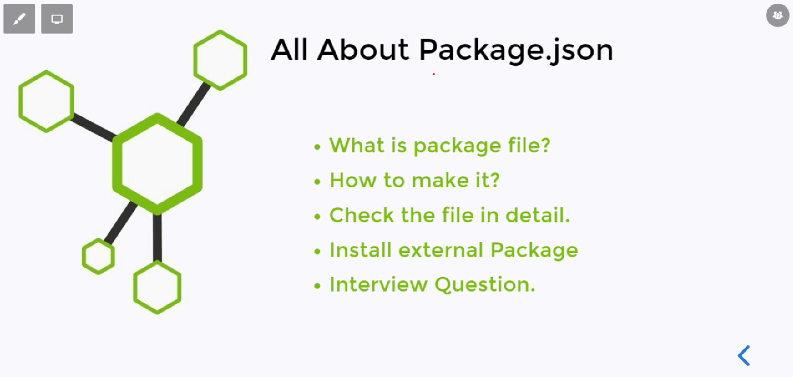
-Package.json is entry file of the Project.
-It contains the Project Details.
-You can create the package.json files in two ways
1]npm init
-It creates the step by step.
-Taking step by step manually information
2]npm iniy -y
-It directly create file with the default information.

Package-lock-json
-It contains the details about the packages.

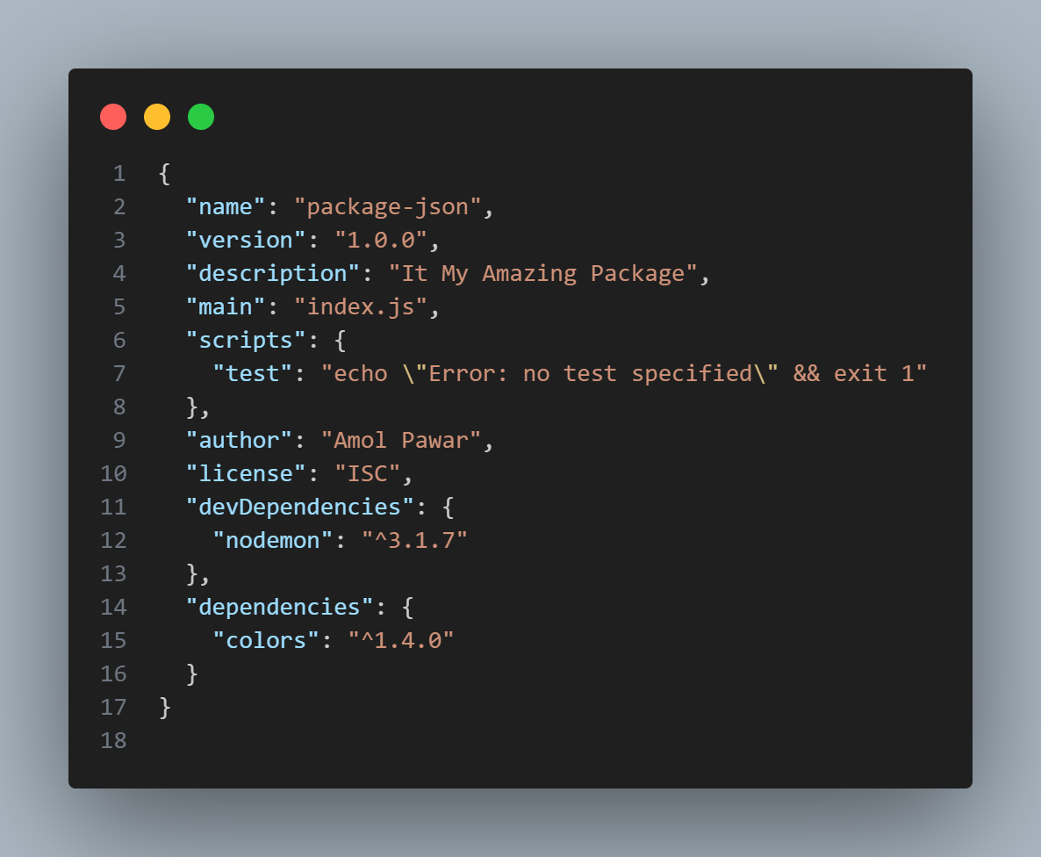
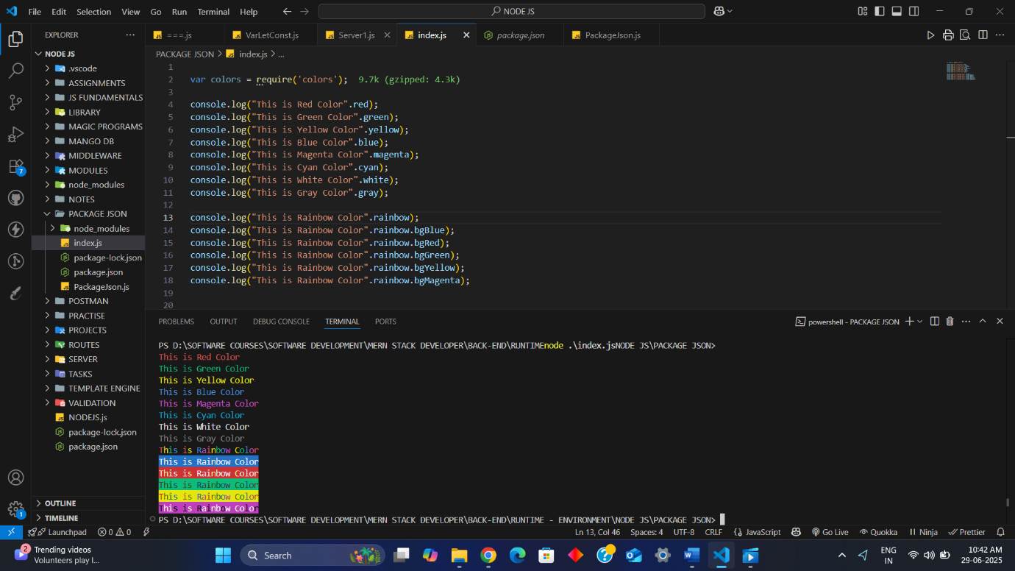

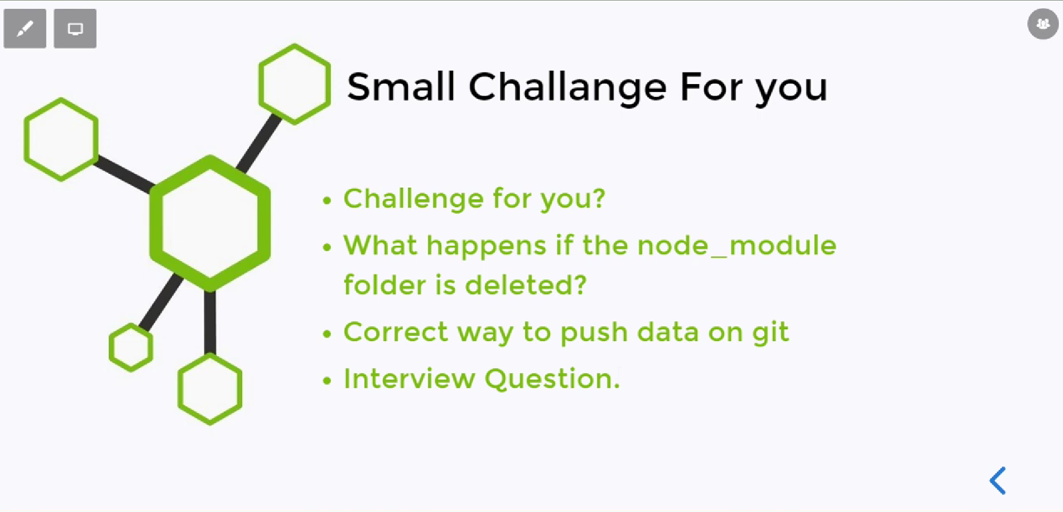
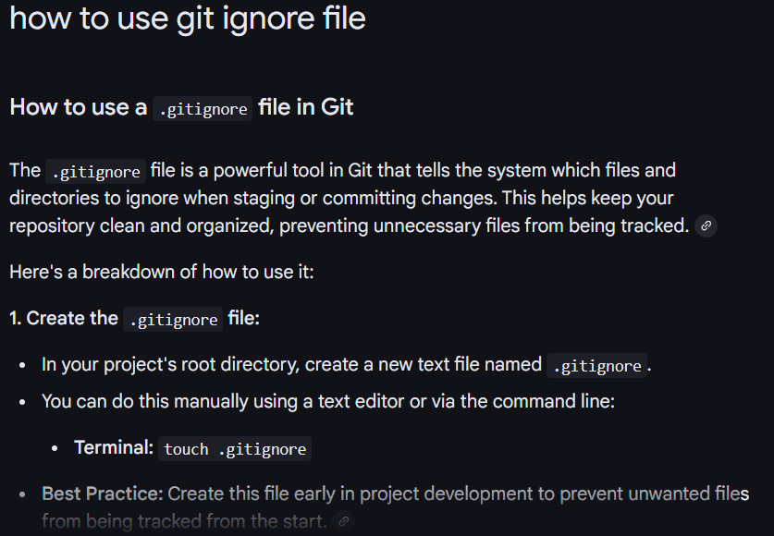
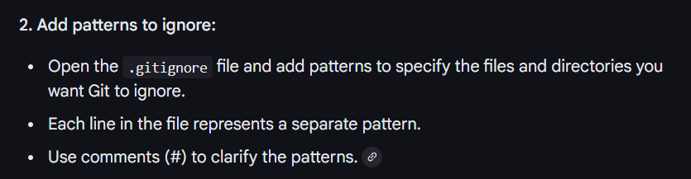
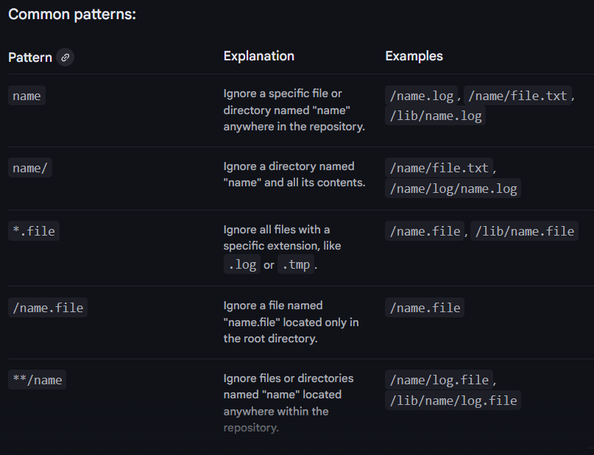
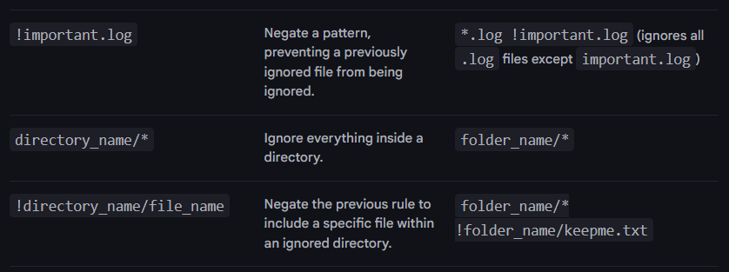
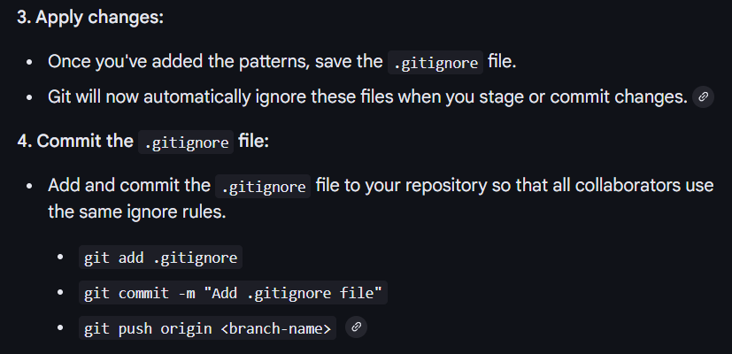
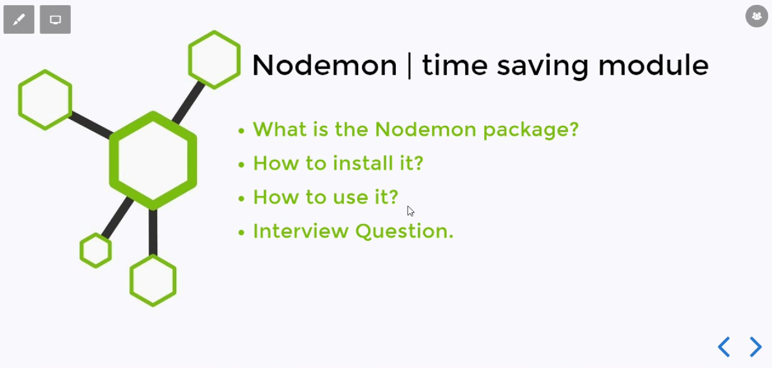
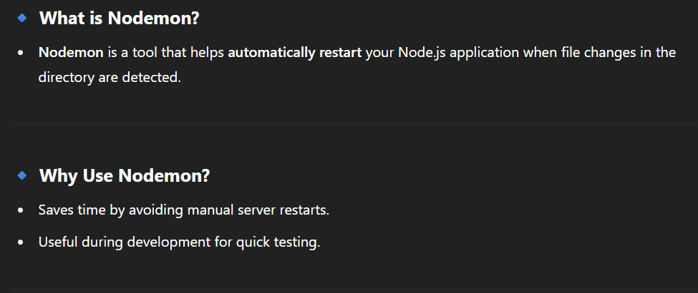
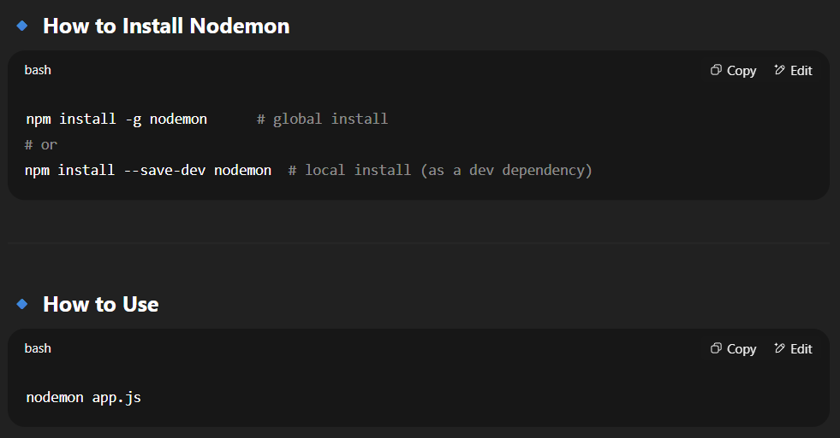
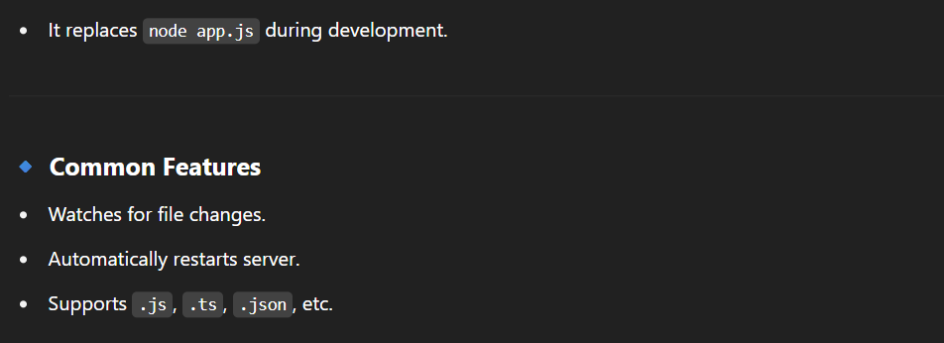
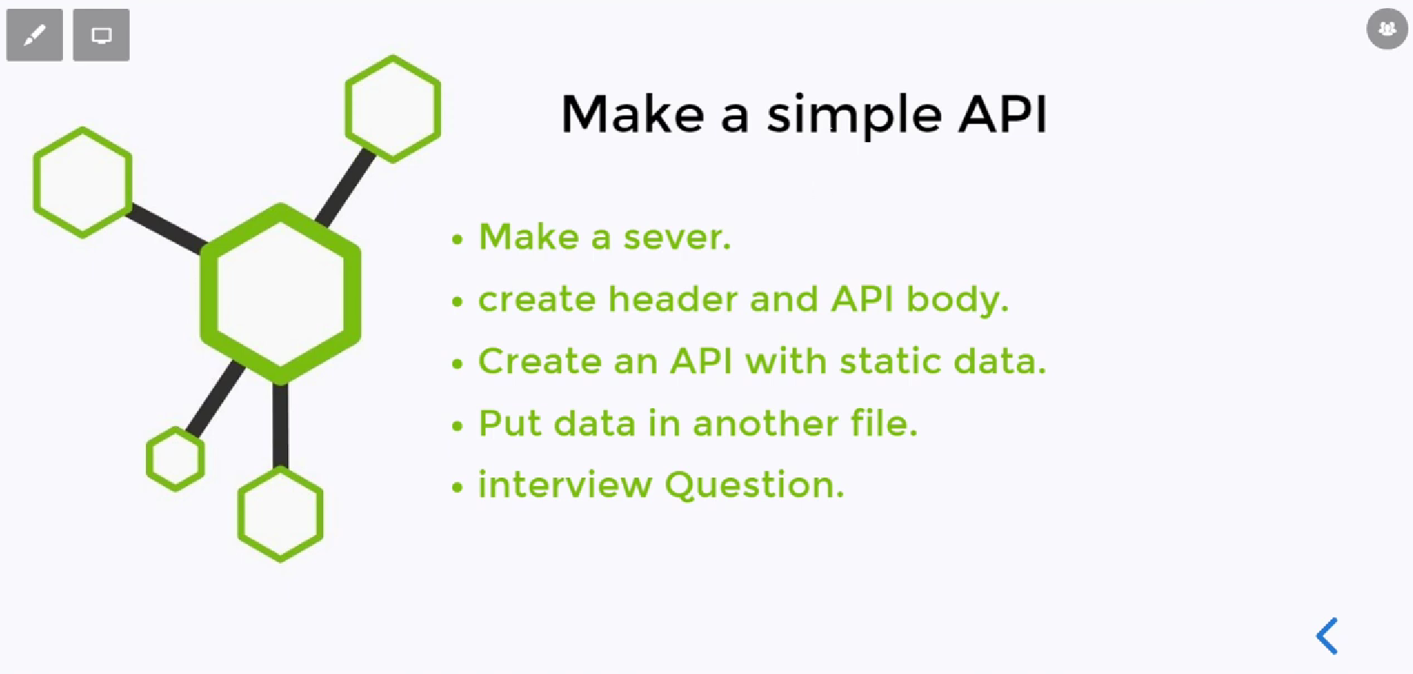
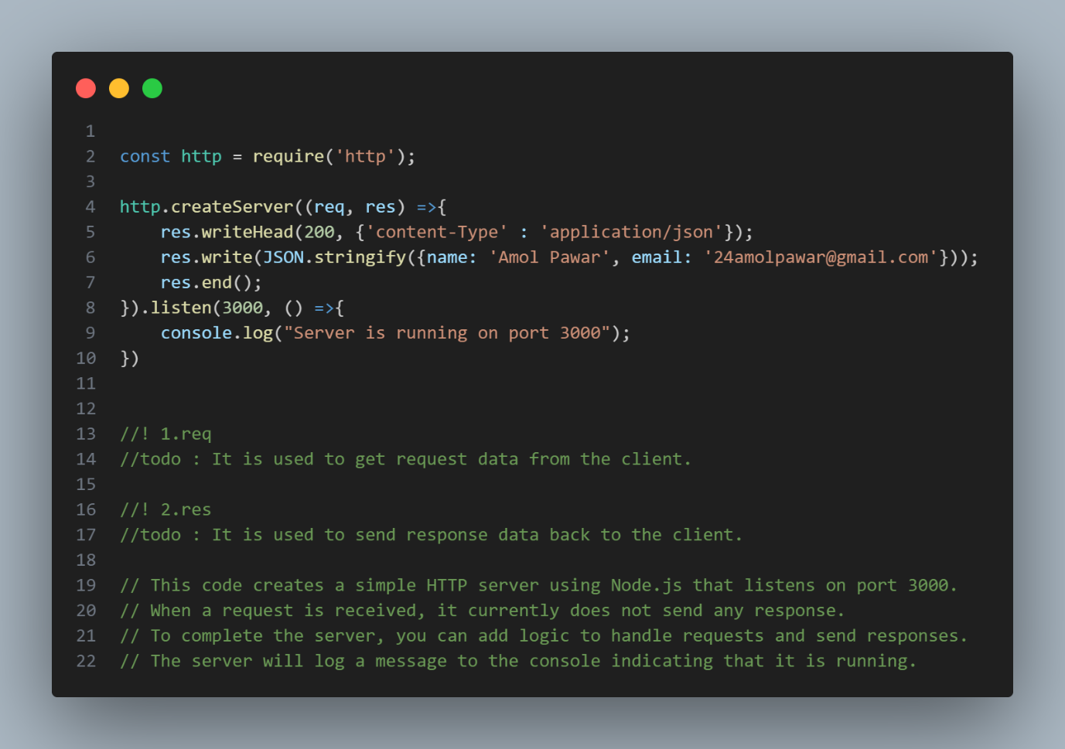
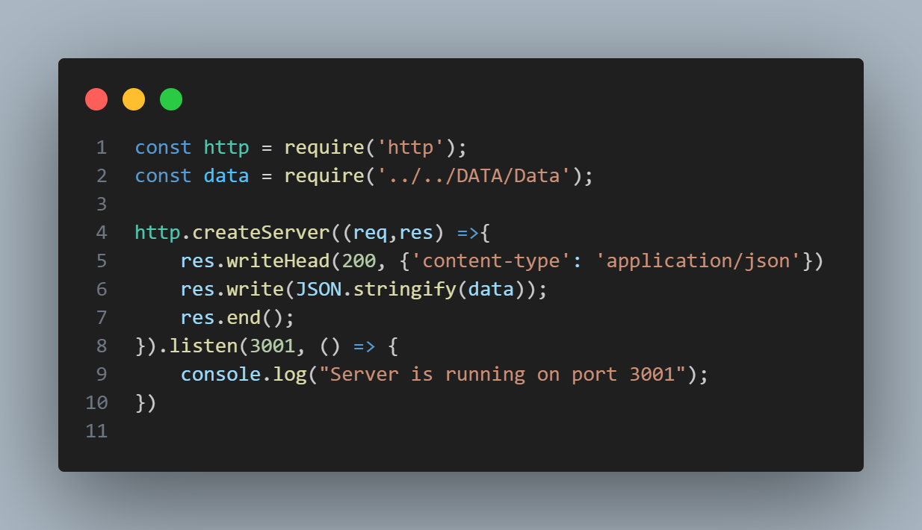
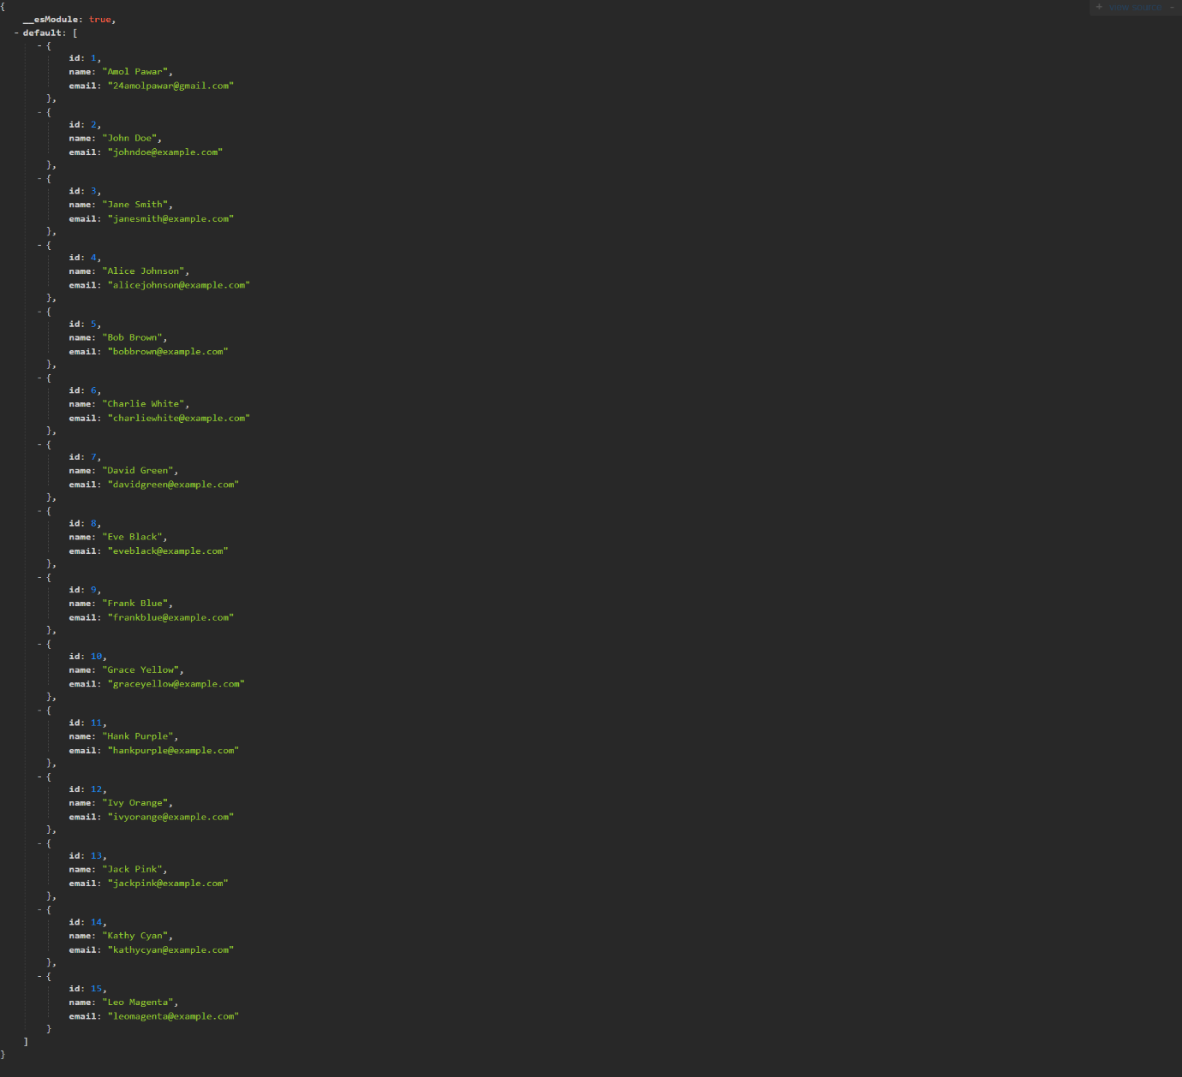
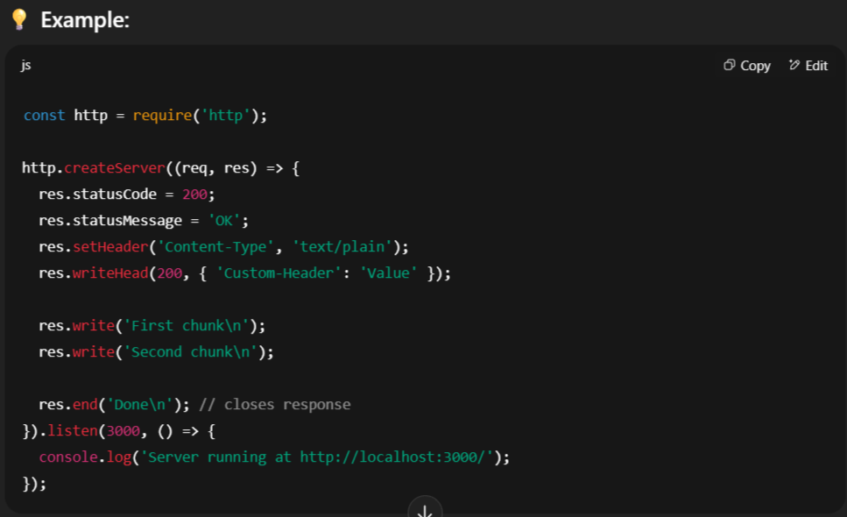
Here’s a complete list of commonly used res (response) methods and properties in Node.js http module — especially those from the Writable stream and HTTP layer:

✅ HTTP res Methods
Method / Property | Description
res.write(chunk[, encoding][, cb]) | Sends a chunk of data to the client.
res.end([data][, encoding][, cb]) | Ends the response. Can optionally send final data.
res.writeHead(statusCode[, headers]) | Sets the HTTP status code and headers.
res.setHeader(name, value) | Sets a single response header.
res.getHeader(name) | Retrieves a specific header value.
res.getHeaders() | Gets all headers as an object.
res.hasHeader(name) | Checks if a header is set.
res.removeHeader(name) | Removes a header.
res.statusCode = code | Directly sets the response status code.
res.statusMessage = 'message' | Sets a custom status message.
res.flushHeaders() | Sends headers immediately without ending the response.
res.writeContinue() | Sends a 100 Continue interim response.
res.setTimeout(ms[, callback]) | Sets a timeout on the response.

✅ Writable Stream Methods (res inherits from stream.Writable)
Method / Property | Description
res.write() | Writes data to the stream.
res.end() | Ends the stream (same as HTTP response).
res.cork() | Buffers writes until uncork() is called.
res.uncork() | Flushes buffered writes.
res.destroy([error]) | Destroys the stream (optionally with an error).
res.writable | Boolean if the stream is writable.
res.writableEnded | True if end() has been called.
res.writableFinished | True if all data has been flushed.
res.writableHighWaterMark | Threshold for write() buffering.
res.writableLength | Number of bytes queued in the buffer.
res.writableObjectMode | True if in object mode.
